

PROJECT 3 – DEVELOPING NATIVE APPS

GROUP 29: Matthew Cormier & Kyle Warner

April 1st 2016

**Table of Contents**

Cover page i

Table of Contents ii

App Description 3

Screen Shots 4-6

**App Name**

B4A - Camera App

**App Description**

Our android app allows the user to take pictures with the back facing camera. The user can set the filename and choose to either append or not append the current date to filename. The app takes the photo and saves it to the root directory with the chosen filename or default.jpg, if left null. The app also allows the user to change the colour scheme from dark to light. Text-to-speech and audio libraries were used read out the last saved filename and to play a beeper when actions take place. To support the older camera library, the app only opens in landscape mode.

Libraries used

* TTS
* Camera
* Audio

View/controls used

* Label
* Edit text/textbox
* Button
* Radio button
* Panel
* Progress bar
* Spinner

Here is the default screen, because this is on the emulator, the camera preview cannot display an actual camera view:

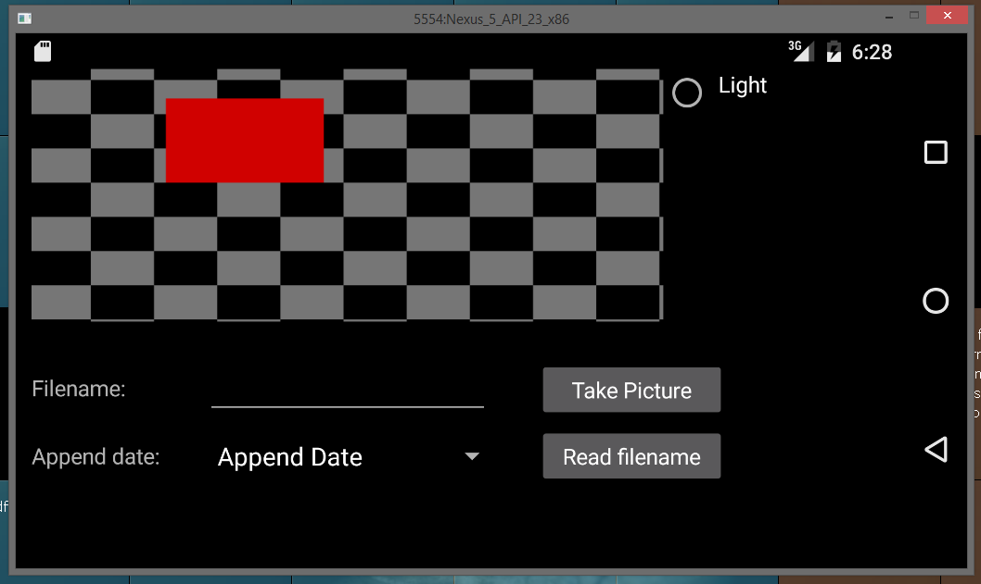

Here is the light theme screen:

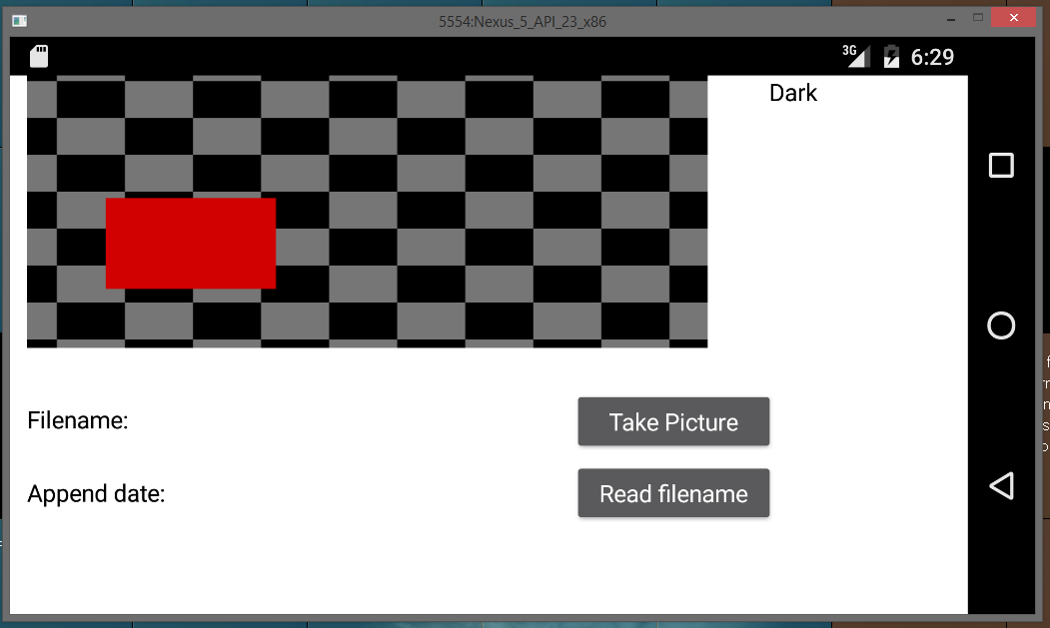

Saving default filename:

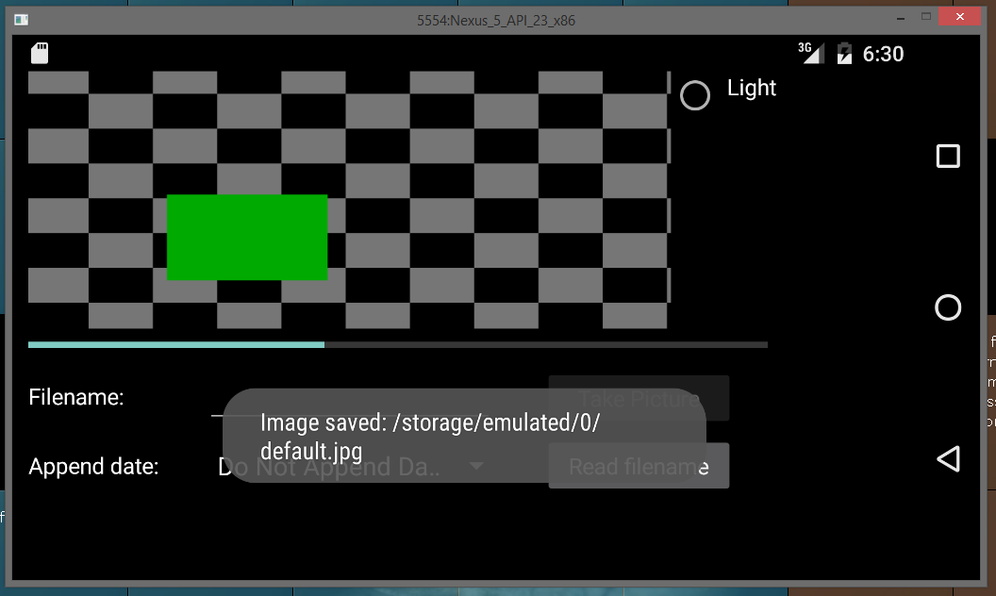

Saving user inputted filename with appended date:

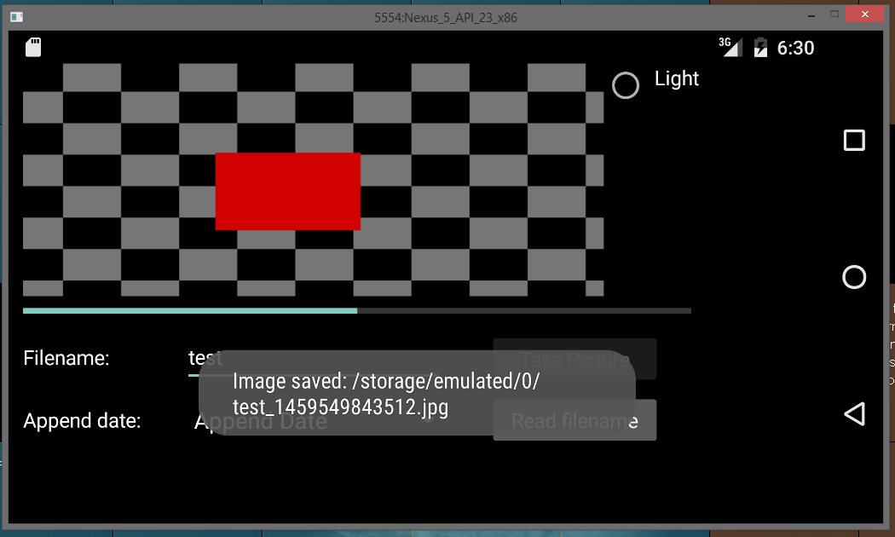

An error displayed when the user inputted an invalid filename:

